NAME -------------------------------------------- STREAM, -----------

MAKERERE COLLEGE SCHOOL
S1. MOT TERM II 2010

MATHEMATICS

Time : 1 Hour.

Answer ALL questions:

1. Given that a ^ b = 2ab - b², find:

(i) 2 ^ -3 (ii) (- 2^ - 1) ^ 3.

2. Solve the equation: 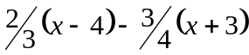 = 2.

3. Express 576 as a product of its prime factors. Hence, find the square root of 576.

4. Solve the inequality:
5(x – 3) - 2(x + 3) ≤ 6(x – 4).
Illustrate your solution on a number line.

5. Express: (i) 734.97 to 1 decimal place.
(ii) 437.8 to 1 significant figure.
- 0.000849 in standard form.
- 0.034083 to 3 significant figures.

6. A father is three times as old as his son. In 12 years’ time, he will be twice as
old as his son. Find their present ages.

7. If x = 1½ , y = ⅓ , z = ⅔ , find the value of 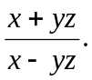

8. Simplify: 



